Drone Drop: build brief for code
Oct 24, 2026 · @Ken

Goal and scope
Build Drone Drop, a one-button-at-a-time catch game in the style of Game & Watch Parachute: a drone drops parcels, the player slides a delivery van to catch them, and a pelican on the right edge causes trouble. The modern skyline version is the main game; the retro LCD handheld is an optional Classic mode skin over the same rules.
- Deliverable: one self-contained index.html (HTML5 canvas or inline SVG, no build step, no external assets except Google Fonts).
- Target: portrait phone, logical scene 390 × 844, scaled to fit; also playable on desktop with the keyboard.
- Input: touch buttons (left, right) or drag; keyboard arrows or A/D; Esc or P to pause.
- Design source: the Design canvas at claude.ai/artifact/6ZumuQbLrEUCneUBXhFEte. Modern row: ModernTitle, ModernDusk, ModernNight, ModernBigVan, ModernOver. Retro row: RetroTitle to RetroBig.
- Out of scope for v1: sound beyond simple beeps, online leaderboards, accounts. Best score is saved in localStorage (wrapped in try/catch).
- Original IP: the retro shell is an original design; do not copy Nintendo's layout, colours or branding.

Screens and flow
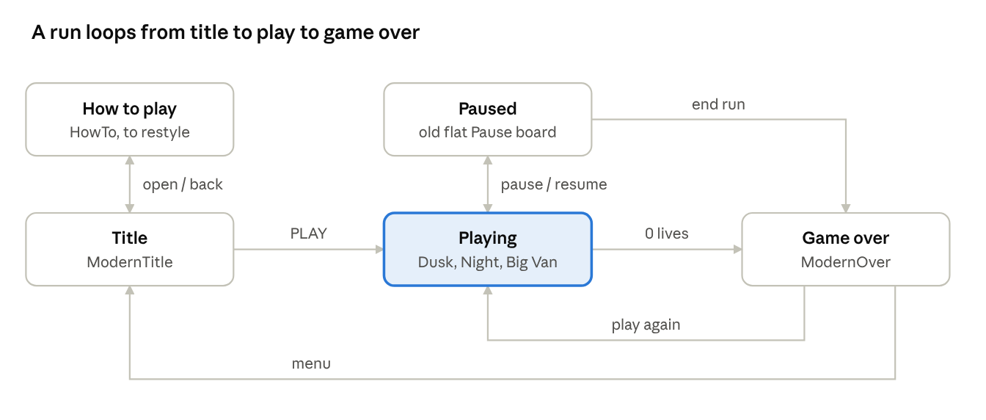
screen flow · 5 states
Playing has three looks (dusk, night, big van) but is one state; the pause button opens Paused, and Paused also offers Quit to the title. Game over shows score, best score and stats (caught, best combo, big vans).

Game rules
The van moves freely along the deck; a parcel is caught when it reaches the van's catch bin while overlapping it horizontally. Everything below is a tunable constant in a single CONFIG object.
- Drone hovers at the top and slides between drop points, releasing one parcel at a time (up to a few in flight at higher levels).
- Parcel falls at the level's speed. If its centre is inside the van's catch width when it crosses the bin line, it is caught: +10 score, combo +1. Otherwise it hits the water: lose 1 life, combo resets to 0.
- Combo: 5 consecutive catches fills the 5-cell meter and triggers BIG VAN.
- BIG VAN lasts 8 s. The van is about 144 px wide (normal about 67 px), the meter drains as a timer, and each catch scores double (+20). Catching during BIG VAN does not add to the combo.
- Pelican perches on a post at the right edge. Every 15 to 25 s (random) it shows a "!" for 1 s, then runs one event: snatch (it flies in and takes the lowest parcel in flight, a miss unless that parcel is already over the van) or fish decoy (it drops a fish; catching the fish breaks the combo and ends BIG VAN, and letting it fall is safe).
- Lives: 3, shown as parcel icons. At 0 lives the run ends.
- Free movement: van x follows input continuously, clamped so the van stays fully on the deck.
Constant | Value | Notes
Scene size | 390 × 844 | Logical units
Lives | 3
Catch score | 10 (20 in BIG VAN) | Shown zero-padded to 4 digits
Combo to trigger BIG VAN | 5 | Resets on any miss or fish catch
BIG VAN duration | 8 s | Meter drains over this time
Van width, normal / big | about 67 / 144 px | Art scale 0.7 and 0.72 of the SVG
Van speed | about 340 px/s | Starting value, tune by feel
Deck line | y = 706 | Catch bin top at 706 − 66 × scale
Pelican event gap | 15 to 25 s | Random per event
Pelican warning | 1 s | "!" bubble above the post

Levels and difficulty
The skyline changes with each level: dusk, then night, then sunrise. The design only fixes the three scenes; the score thresholds and speeds below are proposed starting values to tune in play.
Level | Scene | Starts at score | Fall speed | Parcels in flight
1 | Dusk | 0 | 140 px/s | 1
2 | Night | 150 | 190 px/s | 2
3 | Sunrise | 350 | 240 px/s | 2 to 3
4+ | Cycle back to dusk | every 250 more | +25 px/s, cap 380 | 3
- The scene cross-fades over about 2 s on level-up (skip the fade when reduce-motion is on).
- Level 2 adds the moon, stars and neon signs; the pelican flies in the night scene art (pelF).
- Show the level in the HUD chip: "LV 1 · DUSK", "LV 2 · NIGHT", "LV 3 · SUNRISE".
- Speed ramps gradually inside a level (about +3 px/s per catch) so the jump at level-up is small.

Layout and coordinates
All modern screens share one 390 × 844 scene. Positions are in scene units from the top-left; scale the whole scene uniformly to fit the window.
Element | Position / size | Notes
Horizon | y = 470 | Skyline layers sit above it
Water | below the horizon | Colour per level
Deck | y = 706, height 26 | Van baseline
Pilings | y = 732, height 70 | Under the deck
Van | drawn at translate(x, 706) scale(0.7) | Big van scale 0.72
Pelican post | rect x 364, y 562, 16 × 144; cap x 360, y 554 | Pelican translate(372 554) scale(0.8)
Pelican "!" bubble | translate(346 452) | Shown 1 s before an event
HUD row 1 | top 20 | Score card 132 wide, pause button 48 px circle, lives card 132 wide
HUD row 2 | top 92 | Combo meter (5 cells) or BIG VAN bar, level chip
Controls | bottom 22 | Two buttons, 68 px high
Drone | y about 196 | Slides horizontally, sprite scale 1
Parcel | 38 × 30 | Falls from the drone
- Van travel: the full deck width, clamped so the sprite stays on screen. The design shows a ghost trail at x 70 and 310 to suggest the range.
- Pelican perch is inside the right edge; keep van travel and parcels from being hidden behind the post (the post is behind the van in draw order).
- The old three-lane x values (78 / 190 / 302) are only drop-point suggestions for the drone, not van positions.

Design tokens
Define these as CSS variables or a THEME object. Sky layers use one shared skyline geometry recoloured per level.
Token | Value
Ink / outline | #141A45
White | #F4F1FF
Cyan (van stripe, bin) | #3DF0E0, dark teal #12807A
Amber (parcels, play button) | #FFB347, light #FFD27D, dark #E5871F, button shadow #B8731A
Pink | #FF5C8A
HUD glass | rgba(11,16,48,0.78), border 1.5px rgba(255,255,255,0.16)
HUD label | #B9C2F5
Level chip text | #FFD27D
Fonts (modern) | Space Grotesk 500 / 700, Space Mono 700 for digits
Fonts (retro) | Silkscreen 400 / 700

Level | Sky gradient, top to bottom | Far / mid / near skyline | Water
Dusk | #2A2160, #4A2E7E, #7C3A8E, #C2487F, #F0715F, #FFA06A | #7A3F86 / #4A2C74 / #2A1C52 | #2C3C7E
Night | #070A24, #0C1238, #121A4C, #1A2468, #253085, #34409E | #2A3590 / #161E5E / #0B1140 | #0B1E52
Sunrise | #2F5E9E, #5B8CC8, #8FB4DA, #F4C48A, #FFB070, #FFD08A | #8FA9D0 / #5F7DAE / #3A5788 | #3C74A8

Sprites and asset sources
All art is inline SVG in the design files; copy the <defs> symbols into the game rather than redrawing. Characters use explicit fills with a #141A45 outline. Skyline layers use one geometry with fill set per level.
Sprite id | What it is | Source file in the design project
drone | White capsule body, visor, rotor discs | ModernDusk.dc.html
parcel | 38 × 30 amber two-tone box | ModernDusk.dc.html
van | White body, cyan stripe, cyan roof bin, dark cab window; about 96 wide at scale 1 | ModernDusk.dc.html
vanBig | Wide van, about 200 wide at scale 1 | ModernBigVan.dc.html
pelP | Perched pelican, orange bill and pouch | ModernDusk.dc.html
pelF | Flying pelican for the snatch event | ModernNight.dc.html
fish | Decoy fish | ModernNight.dc.html
skyFar, skyMid, skyNear | Skyline layers | ModernDusk.dc.html
Retro skin art (seven-segment polygons sa to sg, d8, pelP, pelU, pelD, fish, vanBig) is in the Retro* files; the same ids are used across them.
The design project files are in the session scratchpad under drone-drop/project/. If the coder cannot reach them, ask for an export of the artifact and read the <defs> blocks.

Retro LCD skin (Classic mode)
Same rules, different rendering: a landscape 800 × 480 handheld with the game on a fixed LCD grid. Build it after the modern game works, as a render swap over the same game state.
- Shell: rect rx 32 #2B3A67, plate #C9D3E3, bezel #1B2340. LCD rect x 166, y 92, 468 × 278, fill #B9C4A7. Draw LCD content in a group translated to (166, 92).
- Ink: #222819. Draw "ghost" segments for every unlit position at opacity 0.09; add a glare polygon at 7% white.
- Digits: seven-segment polygons sa to sg via d8.
- Grid: three lanes at x = 78, 234, 390. Drone y = 46. Parcel rows y = 84, 124, 164, 204. Van baseline y = 240. Water dashes at y = 258 and 268.
- Movement is discrete: the van snaps between the three lanes (no free movement). BIG VAN covers two lanes.
- HUD on the LCD: combo cells at x = 140 + 18i, y = 8, 12 × 12; "COMBO" at (140, 34); "BIG" at (244, 22); "MISS" at (322, 23) with parcel icons at x = 392 / 418 / 444, y = 16.
- Pelican perch: post rect x=428 y=228 w=28 h=30, pelican at (442, 206), "!" at (452, 178).
- Buttons: two 76 px orange round buttons at left 46 and left 678, top 262 (left and right). Menu pills at left 668, tops 106 and 156.
- Font: Silkscreen. Known gap: the retro van art has not been shrunk like the modern one.

Code architecture and build steps
Keep game logic separate from rendering so the Classic skin is a second renderer, not a second game.
- State machine: title, howto, playing, paused, gameover.
- Game state: score, best, lives, combo, bigTimer, level, vanX, parcels[], pelican { phase, timer, event }, fish[].
- Loop: requestAnimationFrame, fixed-step update (60 Hz) with delta-time clamped to 50 ms; pause stops the update but keeps rendering.
- Render order (back to front): sky gradient, skyline far, mid, near, water, pelican post and pelican, pilings, deck, van, parcels and fish, drone, HUD.
- Collision: a parcel is caught when its bottom crosses the van's bin line while its centre x is within the van's catch width. No other collision shapes are needed.
- Input: pointer and touch on the two on-screen buttons, arrow keys and A/D, Esc or P to pause. Honour prefers-reduced-motion for the level fade.
- Persistence: best score in localStorage inside try/catch; the game must work without it.
Build order:
- Static scene: scene scaling, sky, skyline, water, deck, van, HUD.
- Van movement and the drone with falling parcels, catch and miss, lives, score.
- Combo meter and BIG VAN.
- Pelican perch, warning, snatch and fish events.
- Levels: speed ramp, scene palette cross-fade.
- Title, pause and game over screens wired to the state machine.
- Restyle the How to play screen to the modern look (currently the old flat design).
- Classic mode retro renderer.

Acceptance checklist and design gaps
- ☐ Runs from a single index.html on a phone and a desktop browser
- ☐ Van moves freely across the deck on touch buttons and keyboard, and never leaves the screen
- ☐ Van looks the same size as the modern mockups (about 67 px, big van about 144 px)
- ☐ Catching 5 in a row triggers BIG VAN for 8 s with the meter draining; a miss or fish catch resets the combo
- ☐ Pelican warns with "!" for 1 s, then runs snatch or fish every 15 to 25 s
- ☐ 3 lives; game over at 0; best score survives a reload
- ☐ Skyline changes dusk, night, sunrise as levels rise
- ☐ Pause works and resumes cleanly
Design gaps to resolve:
- The How to play screen (HowTo) is still the old flat design; the modern title links to it.
- There is no modern Pause screen yet; the old Pause artboard is flat.
- The retro van art was not shrunk to match the modern van.
- Nothing in the mockups has been rendered and checked by a person yet; verify sprite proportions in the browser.
- Score thresholds, speeds and van speed in this brief are proposed starting values, not from the designs.

